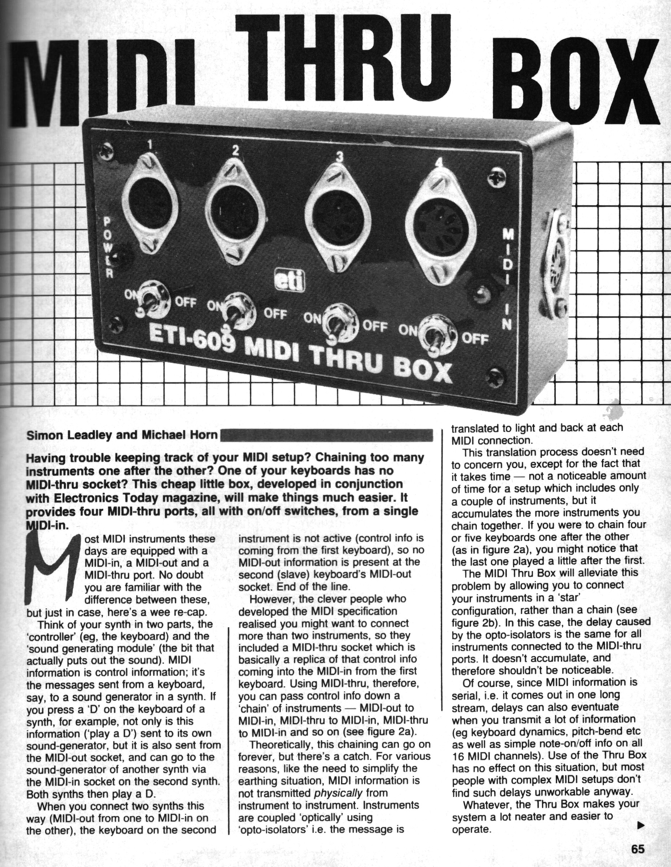
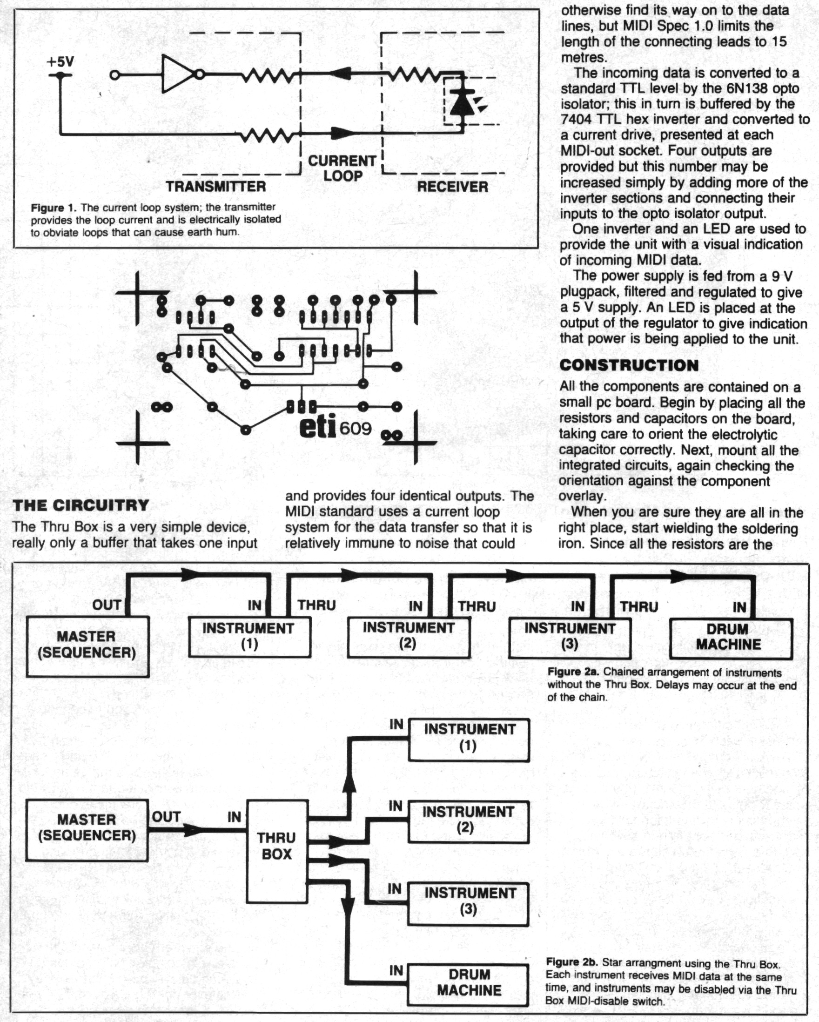

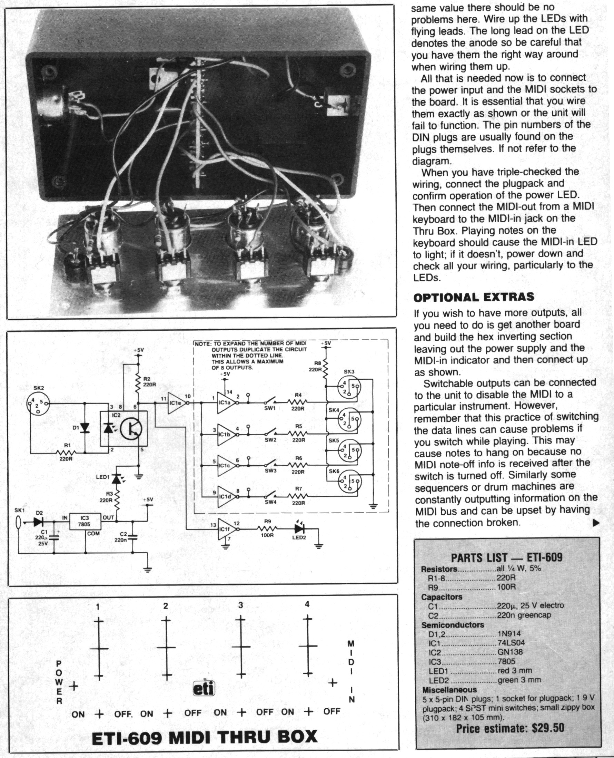

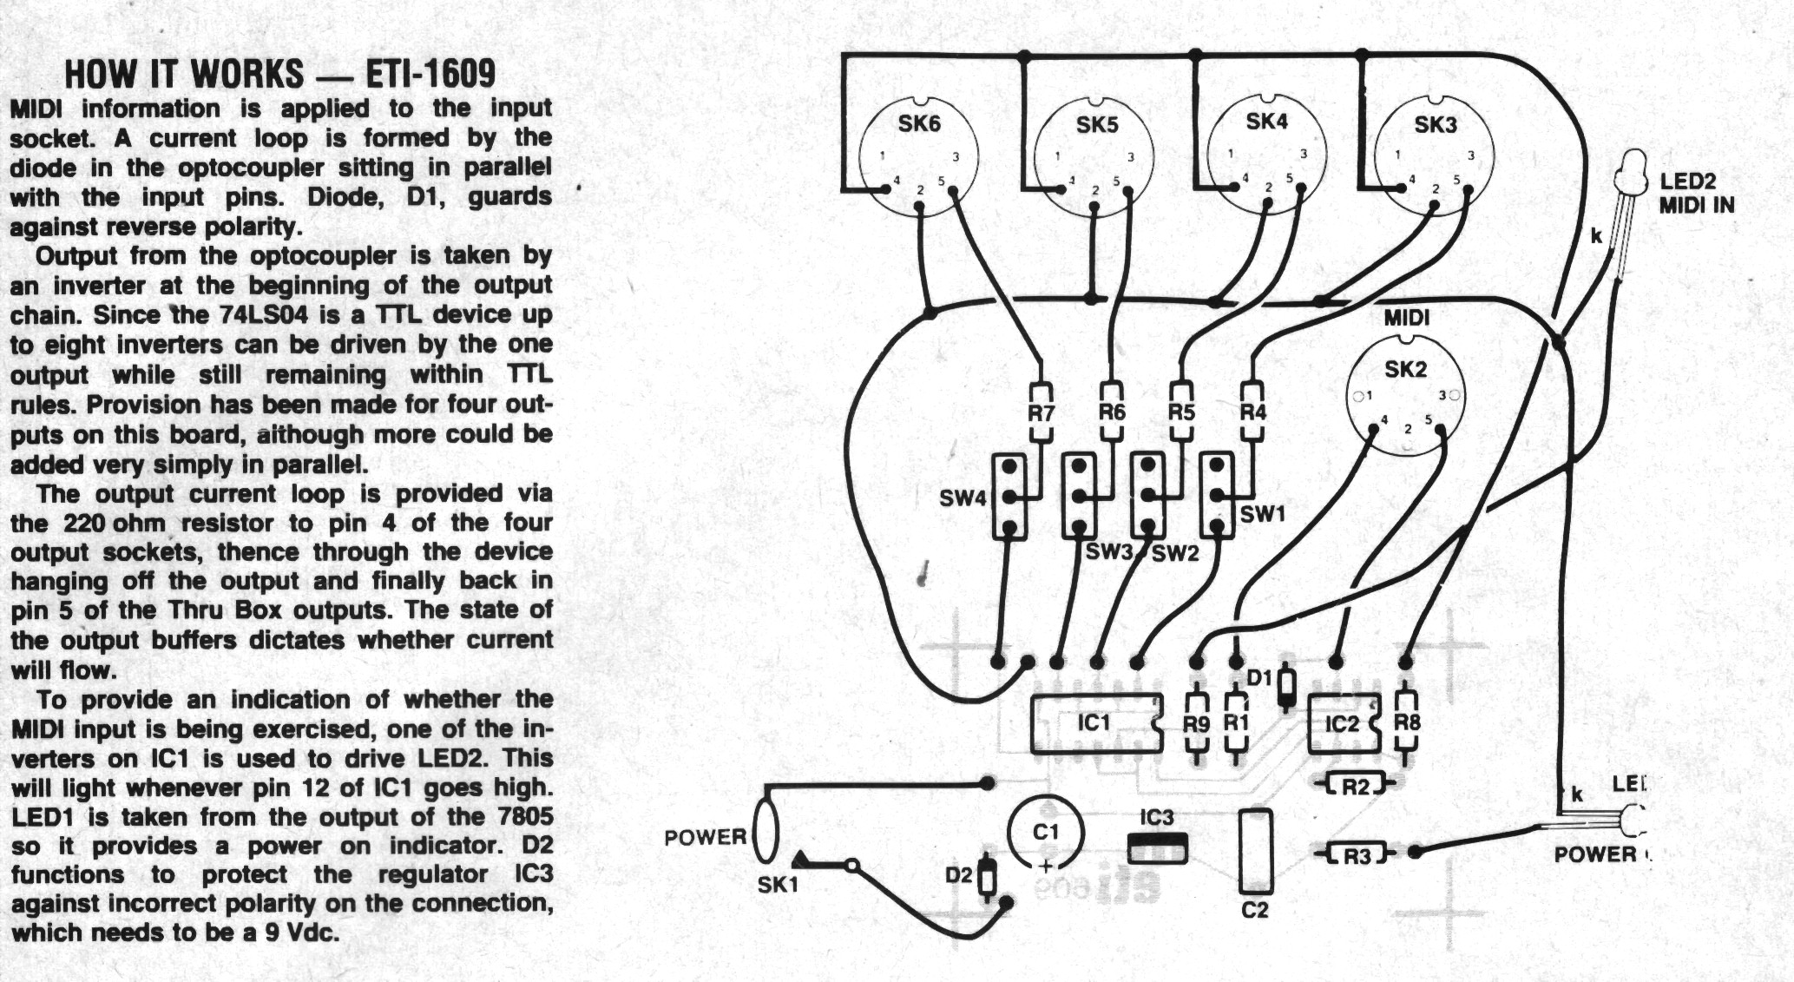
+V in
0V GND
+5V
0V
Connect wires here to power HIGHLY LIQUID's MIDI IN kit circuit off this board instead of places shown in its instructions (won’t drain batteries if powered from here)

